Activity Report (Year 5) for Award 2045887

August 12, 2026

This final report summarizes the activities and accomplishments supported by NSF Award 2045887 during the fifth reporting period and places the year's work in the context of the completed CAREER project. The project began with a computational question: whether electrolyte degradation could be described as a chemical reaction network rather than as a collection of isolated reduction reactions. The work completed this year shows how that description can be used in two directions. It can explain the reactive interfaces that form in concentrated lithium electrolytes, and it can predictively guide the design of electrolytes for new beyond-lithium battery chemistries. The project also produced a durable educational partnership with Dillard University that now extends beyond the formal award period.
The central research result this year is a pair of studies that connect automated reaction discovery, transition-state searches, microkinetic modeling, and chemical-space exploration. In high-concentration electrolytes, anion-derived fragments were shown to create specific, kinetically accessible pathways for solvent decomposition and the formation of inorganic and organic interphase species. In fluoride-ion batteries, an evolutionary search over more than 10,000 candidate solvents identified nitrogen-containing heteroaromatic structures as a convergent design motif, with pentafluoropyridine predicted to have a 2.3-fold longer half-life than the benchmark bis(2,2,2-trifluoroethyl) ether that represented a breakthrough fluoride solvent at the start of this project. These results provide a mechanistic basis for continuing to study reactive electrolytic interfaces and a practical route for extending the methodology to battery chemistries beyond lithium.
The broader impacts work also matured during the final year. The collaboration with Dillard University and Tomekia Simeon, a chemistry and physics faculty member, developed into a sustained program that was interrupted during my move to Notre Dame but which will resume in the form of winter schools in scientific AI for Dillard students. Two students who participated in the CAREER program have now matriculated into PhD programs in applied mathematics and chemical engineering. In the coming academic year, Dillard and Notre Dame will co-host a Scientific Artificial Intelligence school in New Orleans. This is a fitting continuation of the project because the educational partnership now carries the same connection between chemical questions, computation, and scientific AI that defined the research program.

What are the major goals of the project?

Electrolyte development remains a bottleneck for improving battery energy density, longevity, cost, and safety. Mature carbonate electrolytes have benefited from decades of empirical optimization for lithium-ion batteries, but the same optimization cycle cannot simply be repeated for every new electrolyte chemistry. The overarching goal of this project was therefore to develop computational methods that describe electrolyte degradation under relevant conditions and convert those descriptions into useful chemical guidance. The desired outputs were both fundamental, including reaction pathways and kinetic determinants of decomposition, and practical, including chemically diverse candidate structures and design rules for reducing specific degradation mechanisms.
The research objectives were to adapt low-cost quantum chemistry and automated reaction exploration to electrolyte decomposition, incorporate solvation effects into the resulting reaction networks, and benchmark the approach on emerging battery chemistries. The educational objectives were to provide students with training at the intersection of chemical engineering, computational chemistry, and data science; to develop course materials that make these connections explicit; and to broaden participation in this work through collaborations with institutions that serve students who are underrepresented in graduate education and research.

What was accomplished under these goals?

The project met its research and educational objectives. The final year provided a useful test of the original premise because the methods were applied to two chemically different problems. The first study examined the molecular events that follow anion reduction in high-concentration electrolytes. The second used the resulting reaction-based view of stability as one component of a multi-objective search for fluoride-ion battery solvents. Together, the studies establish a completed workflow from mechanistic network construction to candidate discovery.

Major Activities

The research activities centered on two manuscripts. In the first, we mapped the degradation networks of ethylene carbonate, propylene carbonate, dimethyl carbonate, and acetonitrile in the presence of reactive fragments derived from LiFSI and LiTFSI. The calculations combined graph-based reaction enumeration, transition-state searches, and microkinetic simulations. The result is a molecular description of how anion reduction can initiate solvent reactions that contribute to the nascent solid electrolyte interphase (this study has reviewed positively at Adv. Energy Mater).
In the second study, we developed a reactivity-guided genetic algorithm for fluoride-ion battery solvent discovery. Candidate molecules were evaluated using a combination of quantum-chemical stability metrics and a machine-learned solvation score. The search was designed to preserve chemical validity and synthetic plausibility while allowing the population to move through molecular space. The resulting candidates were then examined with higher-level calculations and molecular dynamics simulations (this study is published in Journal of Physical Chemistry B).
The educational activities moved from short-term student hosting toward an institutional relationship. The work with Dillard University was developed with Tomekia Simeon and involved chemistry and physics faculty as well as students. The relationship has persisted beyond a single summer or proposal cycle. Two students from the program have matriculated into PhD programs, one in applied mathematics and one in chemical engineering. The planned Scientific Artificial Intelligence two-day school in New Orleans will give the partnership a shared activity that includes research, pedagogy, and professional development.

Specific Objectives

The specific objectives of this project remain unchanged from the original project description. In the final report we are updating them to be a bit more forward facing for the new opportunities opened up by this project. These objectives are split between three main research objectives and three educational objectives.
Research Objective 1 - Reaction-network methods for electrolyte decomposition. Automated reaction discovery was used to enumerate and characterize elementary pathways involving both closed-shell electrolyte components and reactive anion fragments. The work completed this year demonstrates that the approach can distinguish kinetically inert bulk electrolyte from the reactive species generated under reducing conditions.

Research Objective 2 - Solvation and interfacial chemistry. Solvent and ion interactions were treated with continuum-solvation calculations, binding free energies, thermodynamic integration, and microkinetic modeling. These calculations clarified how fluoride solvation and fluoride-mediated degradation compete in candidate solvents and how anion identity changes the products expected at an interface.

Research Objective 3 - Emerging battery chemistries. The project was extended beyond lithium-ion electrolytes through a fluoride-ion battery case study. The search identified molecular features that balance fluoride coordination with resistance to fluoride-mediated degradation. The result is a concrete design hypothesis for experimental work on post-lithium electrolytes.

Educational Objective 1 - Training in computational molecular science. Graduate and undergraduate researchers received training in reaction enumeration, transition-state searches, microkinetic modeling, molecular dynamics, machine learning, and scientific communication. Students were given responsibility for implementing methods, interpreting results, and preparing manuscripts rather than serving only as users of established software.

Educational Objective 2 - Course and program development. Research examples from molecular generation, reaction-network modeling, and electrolyte design were incorporated into data-science teaching. The examples make the distinction between forward prediction and inverse design concrete for students from chemistry, chemical engineering, physics, and applied mathematics.

Educational Objective 3 - Broadened participation and durable partnerships. The Dillard collaboration created a pathway into computational research that led to graduate enrollment for two participating students. The planned New Orleans school will extend this activity into the Scientific Artificial Intelligence community and provide a setting in which Dillard and Notre Dame faculty can continue to work together.

Significant Results

Reactive Anion Products Determine the SEI Chemistry of Concentrated Electrolytes – Our high-concentration electrolyte study provides the first reaction-network level mechanistic connection between salt reduction and interphase composition. Under bulk conditions, the parent anions PF6-, BF4-, FSI-, and TFSI- were largely kinetically inert toward ethylene carbonate, with barriers above 60 kcal/mol for the modeled bimolecular reactions. Free fluoride was different. Its nucleophilic attack on ethylene carbonate opened the ring with a barrier of 20.3 kcal/mol, and a competing pathway that produces HF had a barrier of 33.0 kcal/mol. These calculations give a specific molecular explanation for why free fluoride produced from anion-reduction that becomes possible at high-concentrations can initiate solvent degradation even when the unreduced salt anion does not.
The same reaction-network analysis showed how the solvent and salt fragments jointly shape the interphase. Reduction of LiFSI and LiTFSI was modeled as producing F- and CF3-derived species, respectively. Those fragments react with cyclic and linear solvents through different channels, while reduced solvent radicals generate inorganic LiCO3-containing fragments and organic carbonate products. In the microkinetic simulations, open-ring products generally outcompeted their closed-ring counterparts, and LiF formation provided a direct route to an inorganic component of the interphase. The calculations therefore connect a local reaction event at the anode to the mixture of inorganic and organic products expected in the growing SEI.
The solvent dependence is also important. The lithiated ethylene carbonate radical undergoes low-barrier ring opening and forms intermediates associated with both LiF and organic carbonate products. Propylene carbonate has a more diverse decomposition manifold, dimethyl carbonate undergoes facile fragmentation after radical rearrangement, and acetonitrile has no kinetically relevant decomposition pathways in the reduced state examined here. This comparison shows how a common mechanistic framework can separate solvent-specific behavior from the general consequences of anion reduction.
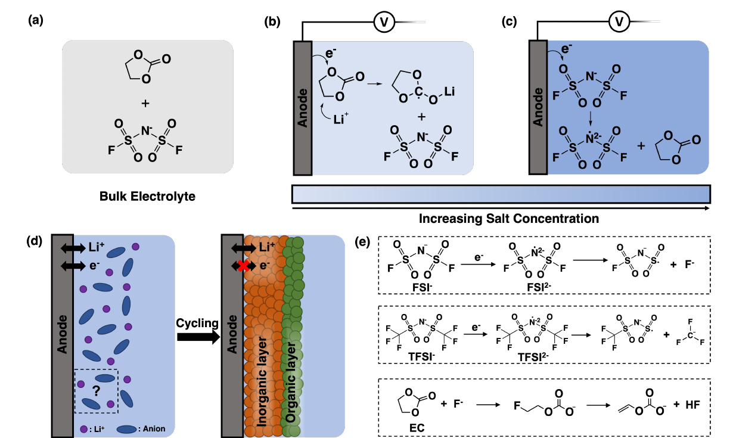
Figure 1. Electrolyte states and anion-mediated pathways analyzed in the high-concentration electrolyte study. Adapted from Figure 1 of E. Akgun; B. M. Savoie, “Anion-Driven Solvent Degradation Networks in High-Concentration Battery Electrolytes” (2026; under review).
Reaction-network methods support post-li electrolyte design. Fluoride-ion batteries offer an especially demanding test for computational electrolyte discovery. Fluoride is the charge-carrying ion, but it is also a strong nucleophile that can rapidly attack organic solvents. A useful solvent must therefore coordinate fluoride sufficiently to support transport while resisting the reactions that consume the electrolyte. Fewer than twenty candidate solvents have been characterized experimentally, which makes a conventional data-driven search poorly conditioned.
The reactivity-guided genetic algorithm addressed this problem by evaluating stability and solvation together. Populations of 50 molecules were evolved for 100 generations, with candidate structures represented by SELFIES strings so that mutation and crossover operations remained chemically valid. Stability was estimated from graph-based enumeration and reaction-free-energy calculations, while solvation was screened with a gradient-boosting model trained on 642 FreeSolv molecules. The highest-scoring candidates were subsequently examined with DFT transition-state calculations, binding free energies, thermodynamic integration, and molecular dynamics.
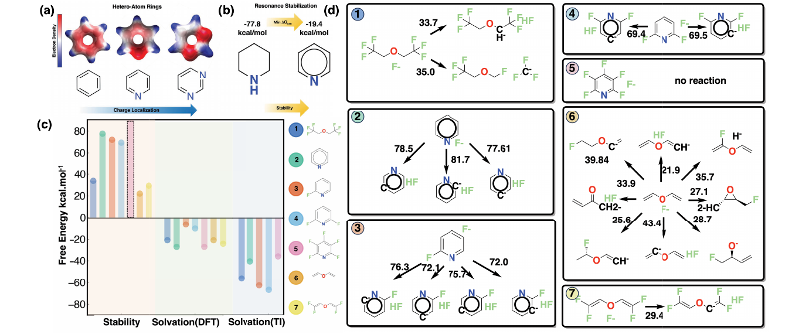
Figure 2. Design principles and validation calculations for the highest-performing fluoride-ion battery solvent candidates from Sathyaseelan V; B. M. Savoie; J. Phys. Chem. B (2026) 130 (27): 6847–6858.
The search converged from both random and benchmark-solvent initializations toward nitrogen-containing heteroaromatic rings. Nitrogen creates a favorable charge distribution for fluoride coordination, while the aromatic pi system provides resonance stabilization against degradation. Pentafluoropyridine had no observed degradation pathway below the 50 kcal/mol kinetic threshold used in the study and was predicted to have a 2.3-fold longer half-life than the benchmark bis(2,2,2-trifluoroethyl) ether under the accelerated simulation conditions. These results do not constitute experimental validation, but they provide a chemically interpretable design rule and a short list of candidates for future testing.

The significance of this result for the CAREER project is methodological as much as chemical. The search did not treat electrolyte stability as a static molecular property. It used reaction enumeration and kinetic surrogates to represent the pathways by which a solvent fails. This makes the framework portable to other carrier ions and electrode environments. The next studies can therefore ask how reactive interfaces develop in sodium, magnesium, fluoride, or other emerging chemistries without rebuilding the conceptual framework from the beginning.

A strong basis for ongoing electrolyte development – The methods developed in this project constitute a comprehensive suite of electrolyte screening and prediction tools that are distinctive for the community and open up many opportunities beyond this project. Automated reaction discovery provides candidate products and transition states. Microkinetic modeling determines which channels can carry flux under specified conditions. Molecular generation and evolutionary optimization then use those mechanistic descriptors to search for molecules with a better balance of properties. The final year's work demonstrated each link in this sequence on a different battery problem.
The platform also clarifies where computation should stop. The fluoride study identifies pentafluoropyridine and related heteroaromatics as promising candidates, but experimental synthesis, conductivity measurements, electrochemical cycling, and compatibility with fluoride salts are still needed. Likewise, the high-concentration electrolyte study describes plausible pathways and product distributions under modeled conditions; it does not replace operando measurements of a particular cell. These boundaries make the future experimental program more focused because the calculations specify which structures, reaction channels, and interphase products should be tested.

What opportunities for training and professional development has the project provided?

The project trained researchers in a form of computational chemistry that requires them to move between molecular structure, electronic structure, kinetics, and data analysis. Students worked with Python, quantum-chemical calculations, transition-state searches, molecular dynamics, machine-learning models, and visualization. They also learned to write about uncertainty and model limitations, which is essential when a predicted reaction network is used to make a design recommendation.
Graduate researchers took increasing responsibility for the technical direction of their projects and for mentoring newer students. The final-year papers were written as mechanistic studies rather than software demonstrations, and the students had to connect numerical results to chemical claims. This progression is visible in the publications associated with the award, which include work led by Vignesh Sathyaseelan and Esra Ulgey Akgun.
The Dillard relationship extended this training model to a new institutional setting. Working with Tomekia Simeon and Dillard colleagues made it possible to introduce students to research questions that would otherwise be difficult to access because they require both chemistry and computation. The most meaningful outcome is that two students from the program have matriculated into PhD programs in applied mathematics and chemical engineering. Their trajectories show that the partnership created preparation for graduate study, not simply exposure to a research laboratory.

How have the results been disseminated to the communities of interest?

The results were disseminated through peer-reviewed articles, a ChemRxiv preprint, conference presentations, group software, and research training. During this reporting period, three award-associated products could be verified as explicitly acknowledging NSF grant 2045887-CBET: two peer-reviewed articles and one preprint. The publications span battery electrolyte degradation, fluoride-ion battery solvent discovery, and reaction-network analysis of primitive carbon fixation. Together they show how the project's methods have been applied beyond a single electrolyte formulation.
The group continued to make computational methods and data available through public code repositories and data archives when appropriate. The use of open reaction-network software and documented computational protocols is especially important for this project because the scientific value lies in comparing complete pathways rather than reporting a single favorable reaction. The papers also state the limitations of the solvation proxies, kinetic thresholds, and accelerated simulations used for screening.

What do you plan to during the next reporting period to accomplish the goals?

Because this is the final report for the CAREER award, there is no subsequent NSF reporting period. The research will continue through the group's broader program in reactive electrolytic interfaces and battery chemistries beyond lithium. Immediate scientific directions include experimental evaluation of the fluoride-solvent candidates, extension of reaction-network models to additional salt and solvent combinations, and integration of molecular generators with reaction-based stability metrics. The NCE will be requested to ensure that completion of publication and dissemination goals for the project, but no new research directions will be pursued.
The educational work will also continue. Dillard University and Notre Dame will co-host a Scientific Artificial Intelligence school in New Orleans in the coming academic year. The school will provide a concrete setting for the faculty relationship with Tomekia Simeon to continue and will connect students from the partnership with a broader community working at the interface of AI, physical simulation, and experiment.

What is the impact on of the development of the principal discipline(s) of the project?

The project contributed a reaction-based framework for electrolyte design that connects elementary chemistry to interphase-scale behavior. The high-concentration electrolyte study shows how anion-derived fragments can be treated as active reactants in the network rather than as labels attached to an otherwise independent solvent-reduction model. The fluoride study shows how those mechanistic descriptors can guide molecular discovery when experimental data are sparse.

The broader contribution is a change in the unit of analysis. Electrolyte design is often organized around isolated molecular properties, while degradation is evaluated only after a candidate has been selected. The completed work makes the degradation network part of the design objective. This gives computational chemistry a more direct role in selecting which molecules should be synthesized and which mechanisms should be tested experimentally.

What is the impact on other disciplines?

The methods developed here are relevant to chemical engineering, machine learning, materials science, and origins-of-life chemistry. Reaction-network exploration supplies a general strategy for systems in which the number of possible reactions is large and short-lived intermediates matter. The evolutionary search provides a way to optimize molecular properties when labeled data are scarce but physically motivated calculations can be performed. The same combination can be adapted to catalysts, separations, polymers, and other reactive materials.

What is the impact on the development of human resources?

The project trained scientists who can work across disciplinary boundaries without treating the disciplines as interchangeable. Students learned enough chemistry to interpret reaction pathways, enough computation to build and diagnose models, and enough scientific communication to explain what a model can and cannot establish. The Dillard partnership broadened the set of students who could access this training and produced two PhD matriculations in applied mathematics and chemical engineering.

What is the impact on teaching and educational experiences?

The research has provided concrete examples for teaching data science and scientific AI. Molecular generation illustrates inverse problems, while reaction-network modeling illustrates why a high-performing local prediction can still produce a poor macroscopic result when it is embedded in a network. These examples are useful because they make the relationship between algorithm design and scientific interpretation visible to students from several majors.

What is the impact on physical resources that form infrastructure?

Nothing to report.

What is the impact on institutional resources that form infrastructure?

Nothing to report.

What is the impact on information resources that form infrastructure?

Nothing to report.

What is the impact on technology transfer?

Nothing to report.

What is the impact on society beyond science and technology?

Batteries support transportation, portable electronics, and grid-scale energy storage, but the chemistry needed to improve them is difficult to optimize by trial and error. Electrolytes are a particularly consequential part of this problem because their reactions at electrode surfaces affect efficiency, lifetime, safety, and the usable voltage range of the cell. By developing tools that connect reaction mechanisms to candidate molecular structures, this project shortens the path between a proposed electrolyte and a chemically informed decision about whether it should be tested.
The project also demonstrates a broader model for scientific training. The Dillard partnership connected research in chemical computation with a pathway into graduate education, and the planned Scientific Artificial Intelligence school will extend that relationship to a wider community. The lasting impact of the award is therefore both technical and institutional: it produced methods for studying reactive interfaces and a network of people prepared to use and extend those methods.
Changes in approach and reasons for change

Nothing to report.

Actual or Anticipated problems or delays and actions or plans to resolve them

Nothing to report.

Changes that have significant impact on expenditures

Nothing to report.

Papers Published and Submitted from this Reporting Period

(1) Jin T., Hsu H-H., Singla V., Savoie B. M., Large property models: a new generative machine-learning formulation for molecules. Faraday Discuss., 2025, 256, 104

(2) Sathyasaleen V., Morgan J. A., Savoie B. M., Kinetics Overcome Thermodynamics in Primitive Analogs of the Reverse Tricarboxylic Acid Cycle. Chemrxiv. 2025. https://doi.org/10.26434/chemrxiv-2025-tjbjd

Papers Published and Submitted from Previous Periods

(1) Iovanac, N. C.; MacKnight, R.; Savoie, B. M. Actively Searching: Inverse Design of Novel Molecules with Simultaneously Optimized Properties. J. Phys. Chem. A 2022, 126 (2), 333–340. https://doi.org/10.1021/acs.jpca.1c08191.

(2) Khot, A.; Savoie, B. M. How Side‐chain Hydrophilicity Modulates Morphology and Charge Transport in Mixed Conducting Polymers. Journal of Polymer Science 2021, 60 (3), 610–620. https://doi.org/10.1002/pol.20210773.

(3) Davies, D. W.; Seo, B.; Park, S. K.; Shiring, S. B.; Chung, H.; Kafle, P.; Yuan, D.; Strzalka, J. W.; Weber, R.; Zhu, X.; Savoie, B. M.; Diao, Y. Unraveling Two Distinct Polymorph Transition Mechanisms in One N-Type Single Crystal for Dynamic Electronics. Nat. Commun. 2023, 14 (1), 1304. https://doi.org/10.1038/s41467-023-36871-9.
(4) Wei, Z.; Wang, X.; Seo, B.; Luo, X.; Hu, Q.; Jones, J.; Zeller, M.; Wang, K.; Savoie, B. M.; Zhao, K.; Dou, L. Side‐Chain Control of Topochemical Polymer Single Crystals with Tunable Elastic Modulus. Angew. Chem. Int. Ed. 2022, 61 (49). https://doi.org/10.1002/anie.202213840.
(5) Kim, S.; Seo, B.; Ramasamy, H. V.; Shang, Z.; Wang, H.; Savoie, B. M.; Pol, V. G. Ion–Solvent Interplay in Concentrated Electrolytes Enables Subzero Temperature Li-Ion Battery Operations. ACS Appl. Mater. Interfaces 2022, 14 (37), 41934–41944. https://doi.org/10.1021/acsami.2c09338.
(6) Gribble, D. A.; Lin, Z.-Y.; Ghosh, S.; Savoie, B. M.; Pol, V. G. Mitigating Polysulfide Shuttles with Upcycled Alkali Metal Terephthalate Decorated Separators. Batteries 2022, 8 (12), 253. https://doi.org/10.3390/batteries8120253.
(7) Khot, A.; Savoie, B. M. Δ-Learning Applied to Coarse-Grained Homogeneous Liquids. The Journal of Chemical Physics 2023, 159 (5), 054104. https://doi.org/10.1063/5.0157742.
(8) Akgun, E. U.; Savoie, B. M. Anion-Driven Solvent Degradation Networks in High-Concentration Battery Electrolytes. ChemRxiv, March 29, 2026. Preprint; explicitly acknowledges NSF CBET grant 2045887-CBET.
(9) Sathyaseelan, V.; Savoie, B. M. Fluoride Electrolyte Discovery via Reactivity Guided Genetic Algorithms. The Journal of Physical Chemistry B 2026, 130, 6847-6858. https://doi.org/10.1021/acs.jpcb.6c01292. Published June 25, 2026; explicitly acknowledges NSF CBET grant 2045887-CBET.
(10) Sathyaseelan, V.; Morgan, J.; Savoie, B. M. Kinetics Overcome Thermodynamics in Primitive Analogs of the Reverse Tricarboxylic Acid Cycle. Chemical Science 2026, 17, 6197-6207. https://doi.org/10.1039/D5SC05872D. Published February 4, 2026; explicitly acknowledges NSF CBET grant 2045887-CBET.

